Debugging
It's time to talk about tools that make it easier to develop, find and fix bugs. The main tool for finding and fixing errors is the debugger.

Start debugging
A debugger is a tool that facilitates the development and debugging of program modules. A debugger provides the following options:
- the ability to debug the execution of modules, both in the file and in the client-server version, and even to debug background jobs
- step by step execution of the module
- setting breakpoints
- interrupt and continue module execution
- evaluation of expressions to analyze the state of variables
- changing variable values during debugging
- viewing the call stack of procedures and functions
- the ability to stop on the occurrence of an error
In 1C Enterprise it is possible to debug using the TCP/IP protocols, as well as HTTP. But we will consider only debugging via TCP/IP, because we don’t want to spend extra time to configure the debug server, as in the case of debugging using the HTTP protocol. The only condition for us is that the network protocol TCP/IP must be enabled at the system.
You can start debugging from designer mode by clicking the "Start debugging" button on the toolbar or in the Debug menu, and also by pressing the hot key F5:
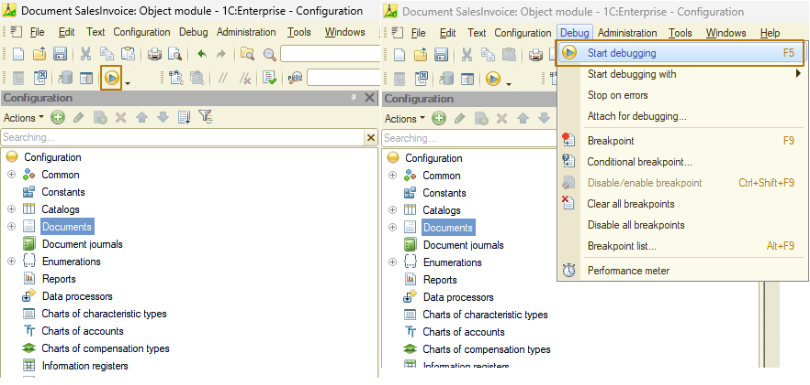
In this case, the most suitable client will be launched (usually a thin client), as if we were launching the Enterprise mode. If you want to launch a different kind of client, you can do so from the menu “Debug - Start debugging with -”.
You can also display additional commands to start debugging on the panel:
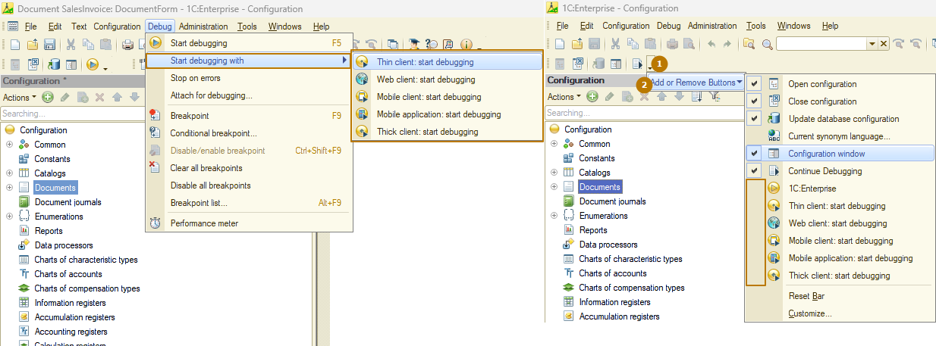
During the whole time of work with connected debugging, the debug start icon will change its appearance to this one.
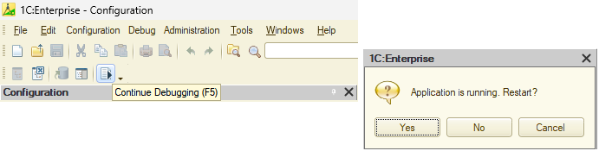
If you click on the button, the platform will issue a warning that debugging is already running and if you continue, the current session will be terminated and a new one will be started.
You can also attach debugging to an existing session. To do this, the session must have the debug connection enabled. You can check this in enterprise mode launched by a user with full rights along the path "Service and settings - Settings - Options":
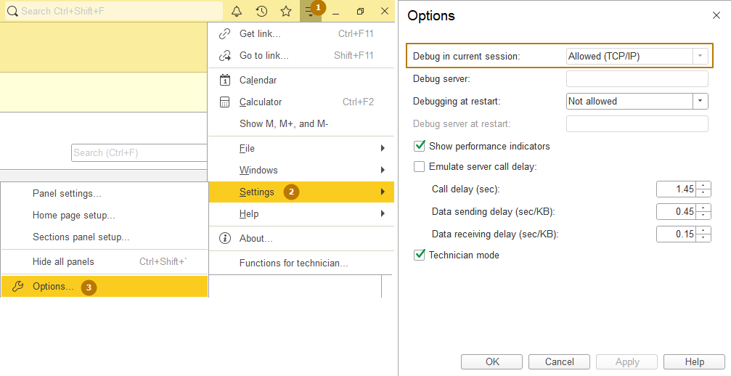
“Debug in current session” property should have “Allowed (TCP/IP)” value.
Now go to the designer and open “Debug - Attach for debugging…” window, where you can see available and already attached for debug sessions. To connect a session to debugging, select it in the top list and click "Attach":
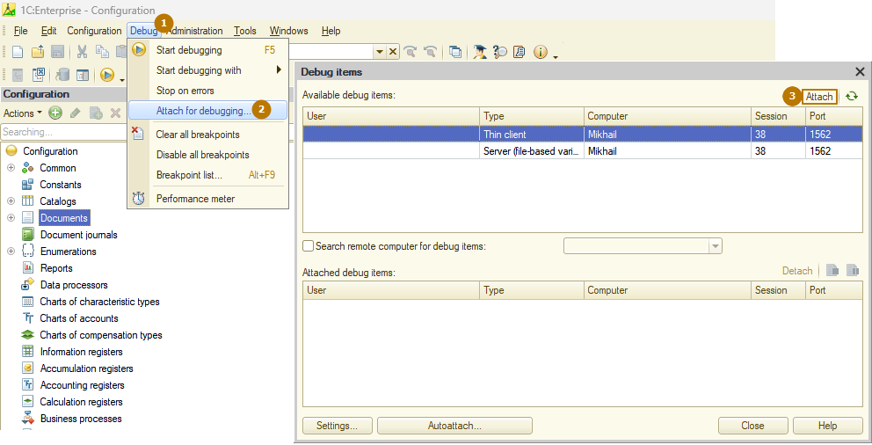
In order to disconnect a session from debugging, select it in the lower list and click "Detach":
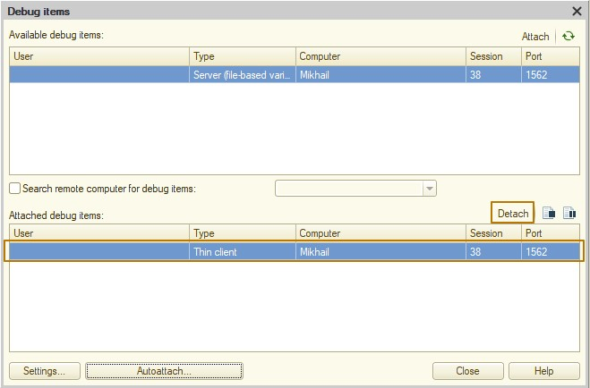
To debug other connection types, such as external connections, HTTP services, and background jobs, you can change the auto-attach settings. To do this, click the “Autoattach…” button and set flags on the required connection types. Then press “OK”.
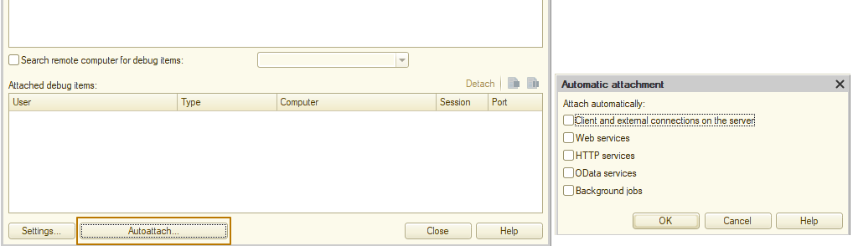

Breakpoints
A breakpoint is a place in the program module where module execution stops, and control passes to the debugger. The current breakpoint, break locations and breakpoint statuses are shown in the left column of the module text, with special marks.
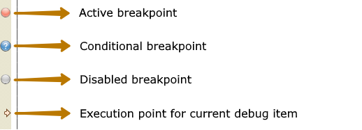
You can set breakpoints in any module line at any time during debugging. If the line with a breakpoint does not contain any operators (e.g., is an empty line), or contains non-executable text (e.g., procedure or function header or variable definition), or is a continuation of the operator started on previous lines, the breakpoint position is automatically adjusted. Breakpoint position is marked with a special character in the left column of the module window. Different characters are used for enabled and disabled breakpoints (see the picture above).
The mouse can also be used to set or remove breakpoints. To do this, double-click in the grey area of the line where you want to set the breakpoint. Use the following commands of the Debug menu in the Designer main menu to manage breakpoints.
Command | Description
Breakpoint | Sets or removes a breakpoint on the line where the cursor is set
Breakpoint with the condition | Sets a breakpoint and opens the dialog box for adding a break condition - a logical expression. If the condition has been added, a dialog box opens to edit the condition. If a breakpoint has been set on this line, a dialog box opens for setting a breakpoint condition for the breakpoint with the condition. Execution stops at the specified breakpoint only if the condition is met
Disable breakpoint | Enables or disables the breakpoint. The command is available if the current line has a breakpoint
Remove all breakpoints | Removes all previously set breakpoints in all modules
Disable all breakpoints | Disables all previously set breakpoints in all modules without deleting them
Breakpoint list | View and manage breakpoints
Stop on Error | If an error occurs, the debugger stops execution and proceeds to the module line that caused the error
Set breakpoints are saved when the configuration is closed. To view the list of breakpoints open the configuration and click Debug - Breakpoint list.
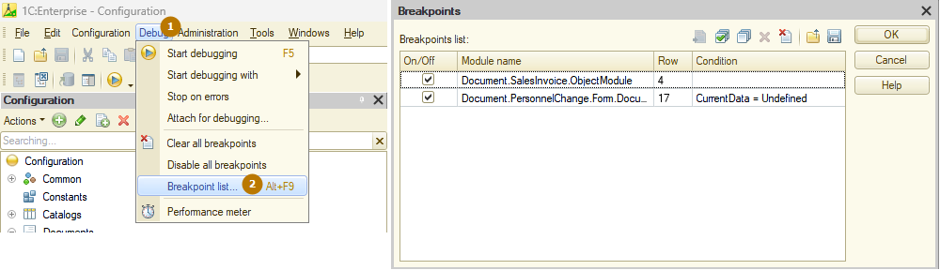
The flag in the On/Off column indicates whether the breakpoint is active or disabled. The "module name" and "row" columns indicate in which module and in which line of the module the breakpoint is set.
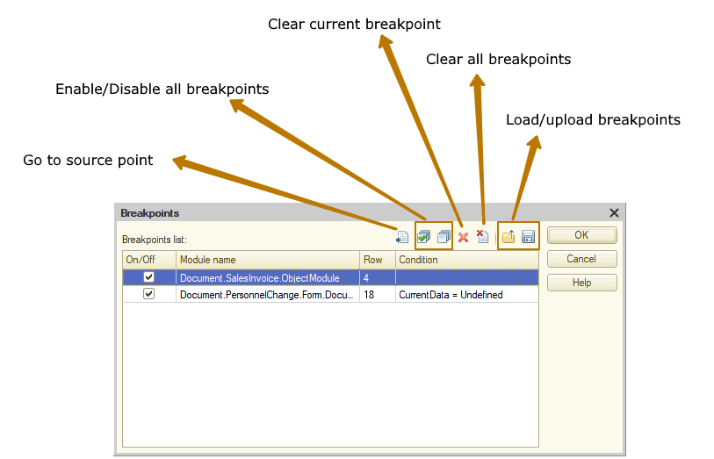

Step-by-step execution
In the step-by-step execution mode, the debug item completes each command and waits for a debugger command to continue execution.
When the first debug item is attached, the system adds debug management commands to the Debug menu.
There are several options for each step of module execution. Use the following commands from the Debug menu to select an option.
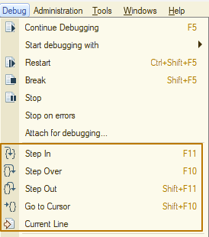
Command | Description
Step In | If the next executable module operator is a function or procedure call, it is incrementally executed, otherwise the debugger proceeds to the next operator.
Step Over | If the next executable module operator is a function or procedure call, it is executed completely (not step by step), and the debugger proceeds to the next operator.
Step Out | Interrupt incremental execution of a function or procedure and stop at the first operator after it is called
Go to Cursor | Interrupt step-by-step module execution, execute all statements up to the line where the cursor is set
Continue | Break the step-by-step module execution and continue free execution
If you need to continue the module execution, select Debug - Continue Debugging to enable free module execution for the attached debug items (up to the next breakpoint). If a client application is attached for debugging, it is activated automatically.
To interrupt the entire debugging process (except for background jobs), remove all breakpoints from all modules and run the Debug - Continue Debugging command, if a breakpoint has been triggered. If you need to interrupt debugging and terminate the operation of the attached debug items, you should use the Debug - Finish command. In the latter case BeforeExit() and OnExit() procedures are not executed.
You can edit the current configuration and save changes during debugging.
Although during the debugging process it is possible to edit the module being debugged, the debugger does not compile the changed code - debugging is continued for the database configuration code (at the moment when debugger is started or attached). To debug the changes made to the configuration, you should update the database configuration.
Table of key combinations for debugger operations can be retrieved in Help when using the application.

Debug management
Let’s learn remaining commands at Debug menu:
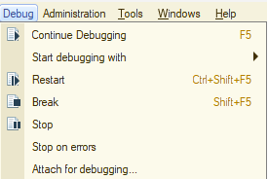
- Restart command stops configuration execution and restarts it in 1C:Enterprise mode. If configuration has been modified, the screen prompts you to update the database configuration.
- Break command stops module execution and terminates the operation of the current debug item.
- Stop command stops module execution on the current operator. This command can be used to start module debugging from the next executable string. This command is useful for module "cycling" analysis.
- Stop on errors command opens the “stop on error” settings dialog box.
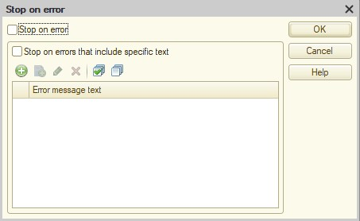
Stop on error check box status defines whether debugging should stop if an error occurs during execution. If execution stops on error, the following warning is displayed: Runtime error and an explanatory text about the location and cause of the error is given.
Example:
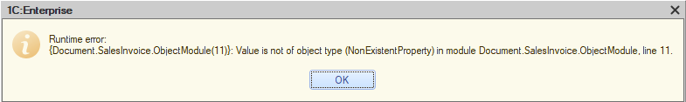
If “Stop on errors that include specific text” check box is selected, then debugging is stopped in the place of an error (if the error message contains the substring indicated in the table field). If this check box is not selected, debugging stops on an error regardless of the error message text. At the same time the specified substring is considered only if you select the check box next to it.
At the place of error, the current execution point of the current debug item is set, and the debug item where the error occurred becomes the current one. Viewing expression and variable values is used to determine the cause of the error.

“Expression” window
During the step-by-step execution, Expressions can be calculated using the Expression window. This window is displayed by selecting the “Debug - Evaluate expression” or “Evaluate expression” at the context menu after right click on some value or using the hot key Shift+F9.
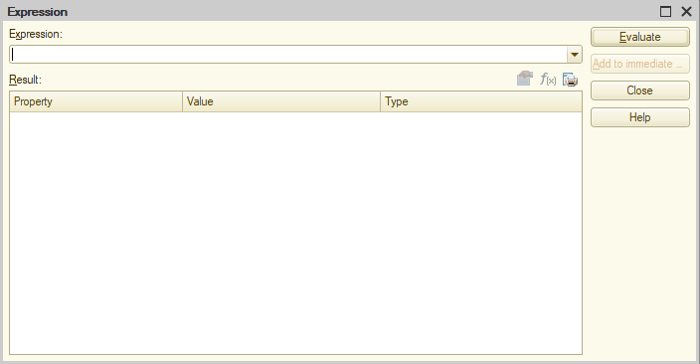
Add the expression in the 1C:Enterprise language into the Expression field of this window. You can add the expression "manually" or select it from a list of previously added expressions.
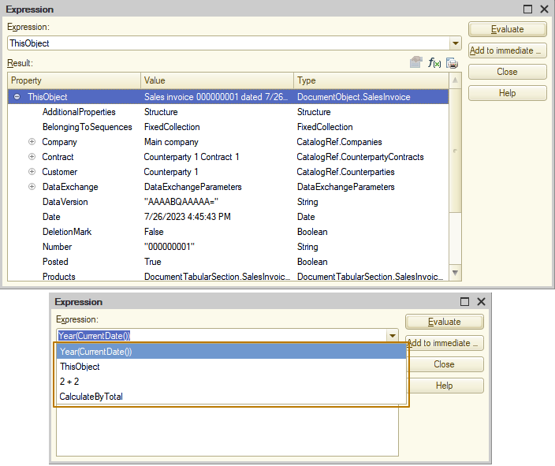
If the cursor in module window was placed over an expression or an expression was selected when calling the Expression window, the expression is automatically inserted into the “Expression” field.
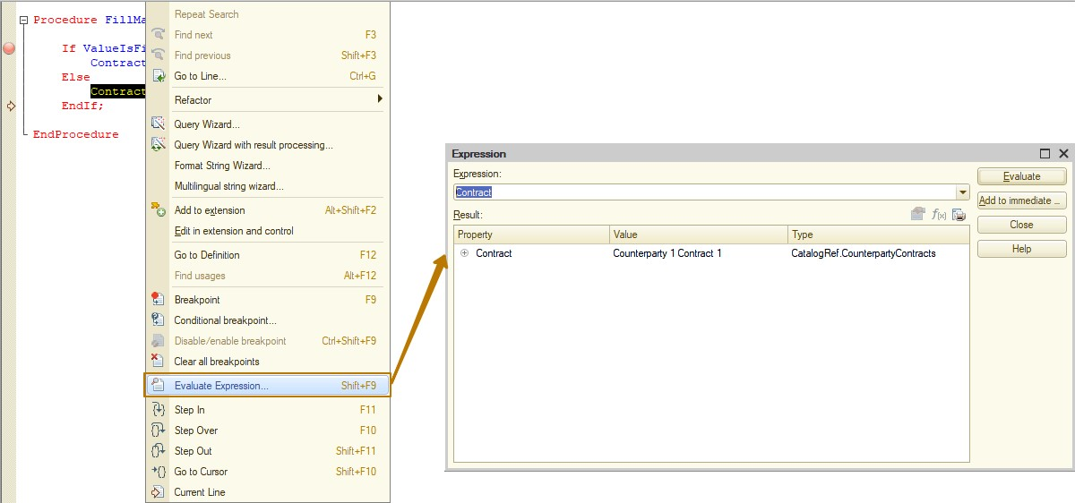
Click Evaluate to calculate an expression. The expression calculation result will be displayed in the Value field. Note that expressions are calculated in a real system, so various side effects are possible. For example, if the calculated expression analyzes the presence of some item in the infobase, and creates the necessary item in its absence, such expression will be executed “along the way” of creation only once. This is due to the fact that after the first execution, the necessary item will be created in the real infobase.
The “Add to immediate …” button adds the entered expression into the immediate window. This may be used to trace the change of calculation result of the expression in the process of module debugging. In this case, the expression is placed into a new line of the immediate window. If there is no immediate window on screen, it opens.
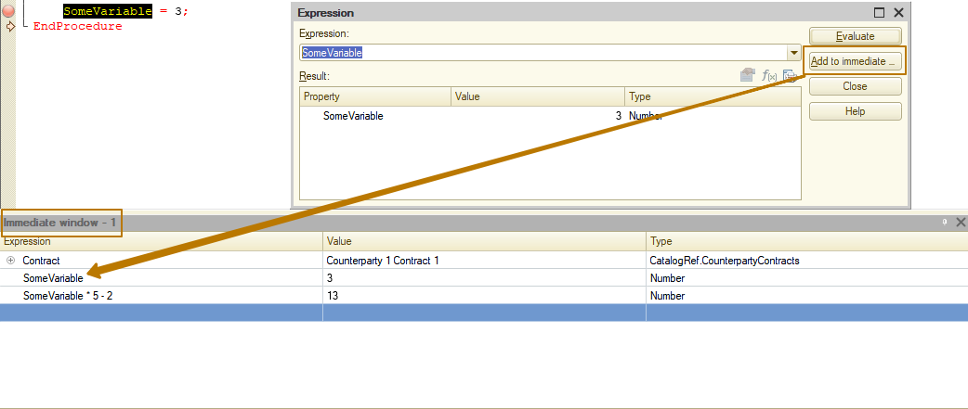
If an expression has a String type or an array or a collection of values, the tools panel button “Show value in a new window” becomes available. For the convenience of viewing long strings, the Evaluate Expression window is displayed. This window contains a control of Label type that displays the line value for viewing. For the convenience of viewing a collection of values or an array, a window containing a table field is opened, columns in this window correspond to attribute names and rows contain attribute values. The window also shows the number of items in a collection and the first column indicates the index of each collection item.
If a specific value is also a collection of values or an array or a row, you can view these values in a separate window. To do this, select the required value in the context menu and select the “Show value in a new window” item or press the F2 key.
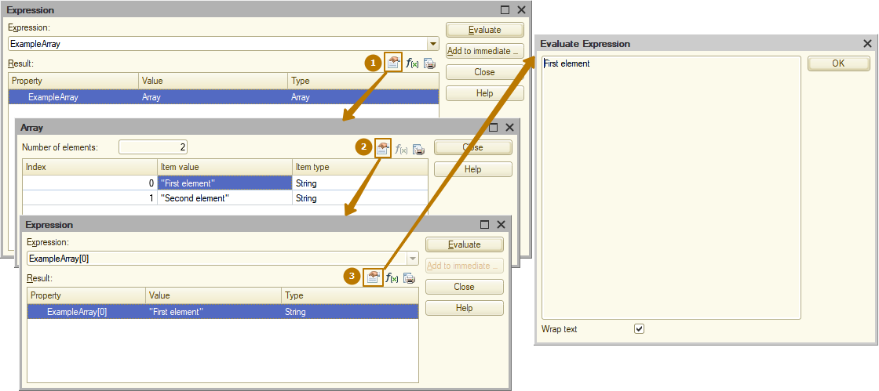
For a string, a window is displayed with the string expression value in a multiline field. You can copy this expression to the clipboard.
The contents of the calculation result table field can be exported to a text or a spreadsheet document using the “Output list” button. If the calculated value is represented as a tree, you can only export data from the opened strings of this tree. 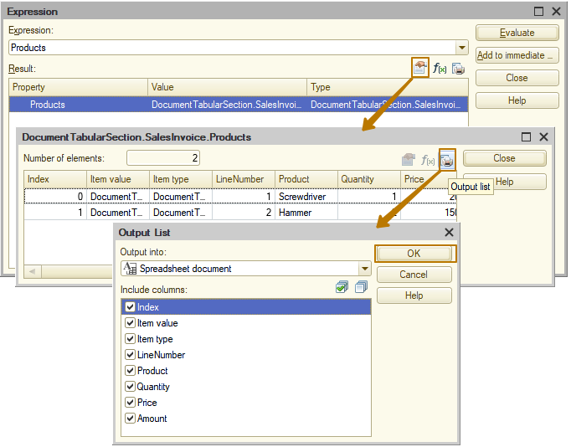
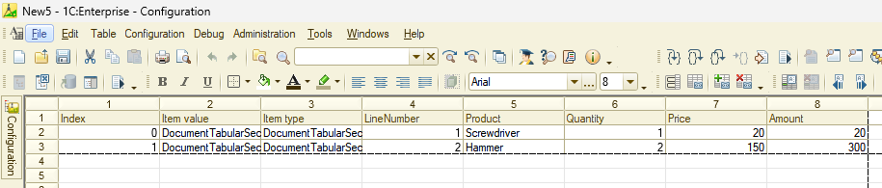
The current value of the expression can also be viewed by moving the cursor over the expression. The current value is displayed as a short tooltip next to the variable. Viewing is possible if the value has a textual representation. This way can also be used to view the value of the property.
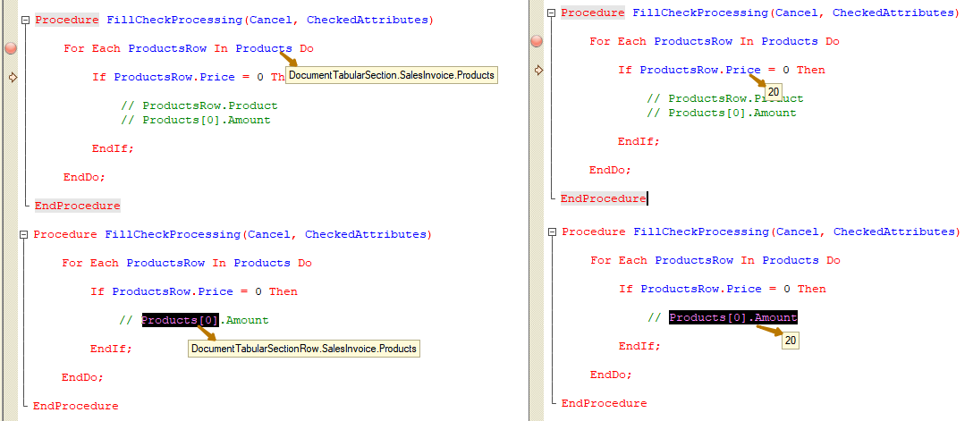
We can even calculate the values of the commented out code. Moreover, in the case of accessing the properties of objects, it is possible to separately calculate some parts of expression by selecting only the necessary part (you can see selected part Products[0] at the picture above).

“Local variables” window
During debugging, it is possible to open a special window that contains a list of local variables of the current method, where the current execution line of the 1C:Enterprise language is located. The window is called up by selecting the menu item Debug - Local Variables, which is available during debugging.
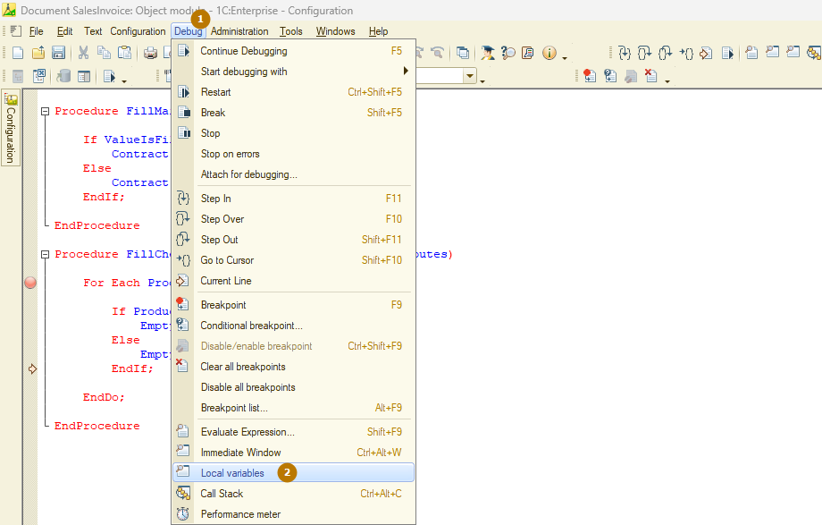
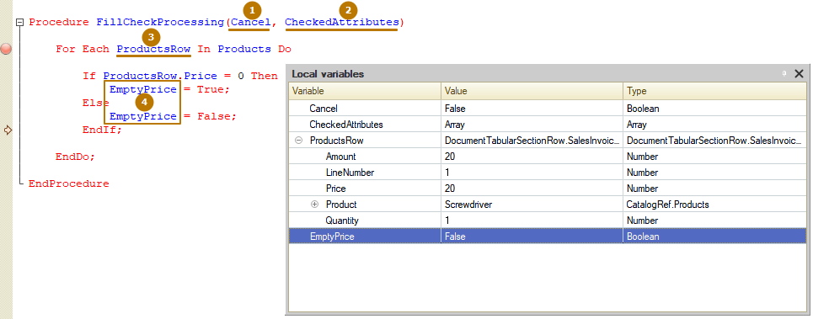
The local variables window contains the parameters of the method being debugged and all local variables used in the method at the current level of the call stack (by default, at the top of the call stack). At the very beginning, the variables are in the uninitialized state. As they are assigned any values, these values appear in the local variables window. You cannot edit the Variable column in this window. The rows composition in this window is not available for editing.
Switching on the call stack, changing the debug item, as well as updating the window contents will be made automatically after each action performed during debugging,
The calculation result can be copied to the clipboard by selecting ”Copy result” of the Value column context menu.
For some data types (see the previous section) it is possible to view the values in a separate window.
Immediate window can also be output to a spreadsheet or text document.
The local variables window can be displayed in various modes. After debugging is complete, the window closes automatically.

Variable value change
When the debugger stopped at a breakpoint, it is possible to change the values of variables and properties of objects available for writing. You can access the change function from the expressions window, immediate window, and the local variables window. In the expressions window, to change the value of a variable, hover the mouse pointer over this variable and click the “Set expression as a value” button (it looks like “f(x)”). After calling the value change function, a special window is displayed for entering the expression. In the upper part of the window, enter the expression which value will be set to the variable. Name of the variable is represented by the header of the expression input field. In the example below it is proposed to change the value of the Amount property of the Products tabular section’s row.
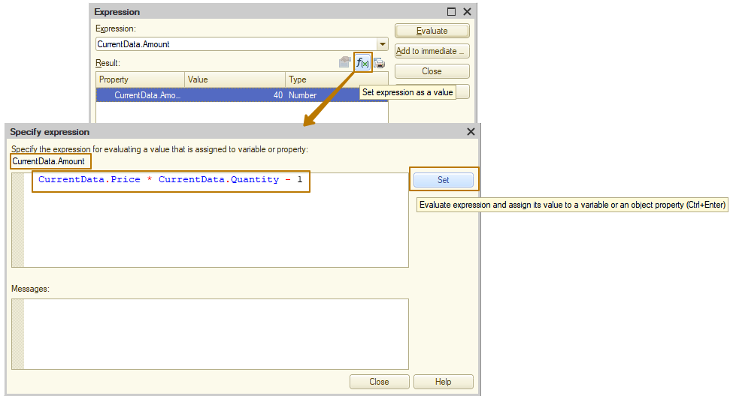
In the expression input window, you can enter constant values of various types, as well as any expressions that are correct in the 1C:Enterprise language. There is a context help in the expression input window that displays the context of the debugger current method.
After clicking the Set button, the installation result will be displayed at the bottom of the expression input window. This could be a phrase ”The value is changed.”, or an error message if there is one.
A value of an expression also can be changed in the immediate window or the local variables window - select ”Set expression as a value” in the context menu of a specific variable. The term "variable" refers to not only the value of an ordinary variable, but also the property of the collection (arbitrary nesting).
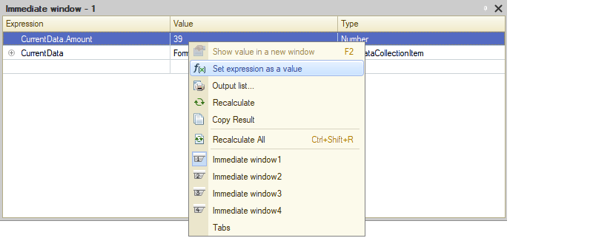

Call stack
Call stack shows the sequence of procedure and function calls that led to the currently debugged module line.
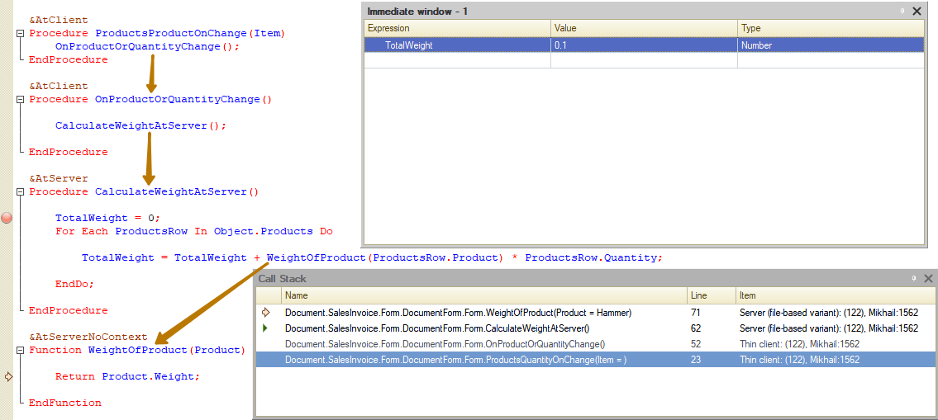
The window shows:
- executed method - the Name column;
- module line number - the Line column;
- the debug item where the module is located - the Item column.
The first column of the window can have two icons:
- The yellow arrow indicates the top of the call stack.
- The green arrow (to the left of the Document.SalesInvoice.Form.DocumentForm.CalculateWeightAtServer() line) indicates a method in the context of which variables are calculated in the Expression window and the Immediate window. If the top of the call stack matches the current context, the green arrow is not shown. To change the context and to set the cursor position to the row indicated in the Row column, doubleclick the required row in the Call Stack window.
In the example shown at the image above, the TotalWeight variable has the 0.1 value, since the debugger is switched to the CalculateWeightAtServer() method context (as indicated by the green arrow next to Document.SalesInvoice.Form.DocumentForm. CalculateWeightAtServer()).
If you switch the context to the top of the stack (double click the row with the yellow arrow), the value of the TotalWeight variable is not defined, because the context switches and other methods don’t have TotalWeight variable.
Some rows in the Call Stack window are shown in grey. This means that you can switch to a module line, but you cannot evaluate expressions in the context of the called method. Thus, those stack items are selected that are "located" on the client, and the top of the stack is "located" on the server.

Performance snapshot
Performance snapshot can be used to evaluate performance of the entire configuration or its part that is running within a debug item of any type. You may measure the use frequency for specific code sections and speed of their execution; specify the code that was executed on the server or -on the client; and indicate the code lines that have initiated server calls. If there are several methods to solve a problem, you may implement them all, and then choose the fastest one.
Please remember that the comparison should be made under the same conditions. For example, if during the task performance using one of the compared methods, the computer processor was performing some other task, this may affect the accuracy of the comparison. There are other, less obvious reasons why the measurement conditions are different. Therefore, when you compare two methods with similar performance, it is recommended to perform several snapshots - for each method for estimating and averaging random scatter.
Use the “Performance meter” at the Debug menu or at the command bar to measure performance. When you select this command again, the measurement stops and the measurement results window opens. Enabling and disabling the performance measuring affect all debug items currently attached to the debugger.
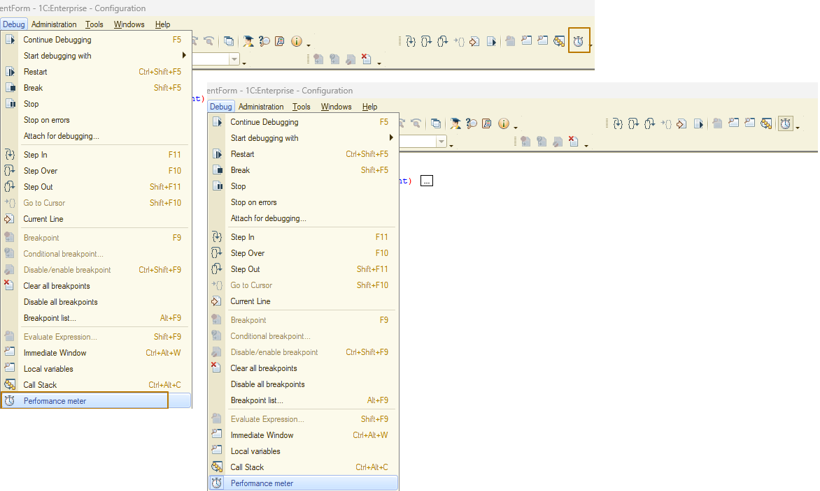

Available action options
If you need to measure the configuration performance, including the system startup section, you must first run the Debug - Performance Snapshot command, and then start 1C:Enterprise. The time elapsed between the start of measurement and the start of system operation is not considered in the measurement results.
If you do not want to include the startup section in the snapshot, first launch 1C:Enterprise and prepare it for execution of the required section. Then switch to the Designer and start the performance snapshot.
If you need to include in the measurement the section that is executed at the 1C:Enterprise shut down, then regardless of whether Option 1 or 2 was used to start the snapshot, you should shut down the program and then switch to the Designer mode. In this case, you do not need to stop the measuring manually. Once the measurement results are ready, they are displayed on the screen.
If no measurement is required for the section executed at the 1C:Enterprise shut down, then the performance snapshot should be stopped to view the measurement results. For example, to analyze the procedure for any document, you need to start the program, open the document and fill it, switch to the Designer mode, start the performance snapshot, switch to the 1C:Enterprise mode, post the document, switch to the Designer mode and finish the performance snapshot.

Measurement results
Measurement results - references to specific module lines that specify the frequency and execution duration. It is displayed as a table box with the following columns:
- Module - contains the name of the module.
- Row number - the module line number;
- Line - the module line text;
- Col. - number of calls to this string during measurement;
- Time (net) - total runtime (in seconds) for this string during measurement;
- %(Time) (net) - percentage of the total runtime for this line to the total snapshot time (total snapshot time equals the sum of all time intervals of executing the configuration code). In this case, 100% is the execution of code on the client.
- Client - this icon (see the image below) marks the code lines that run on the client;
- Server - this icon (see the image below) marks the code lines that run on the server;
- Server proc. (server processing) - these icons mark the code lines that initiate server calls: the server was called at the platform level, or procedures and functions executed on the server were called directly (Direct server call on the image); local call of procedure/function executed on the client, within which the server call occurred at the platform level, or procedures/functions executed on the server were called directly (Nested server call on the image).
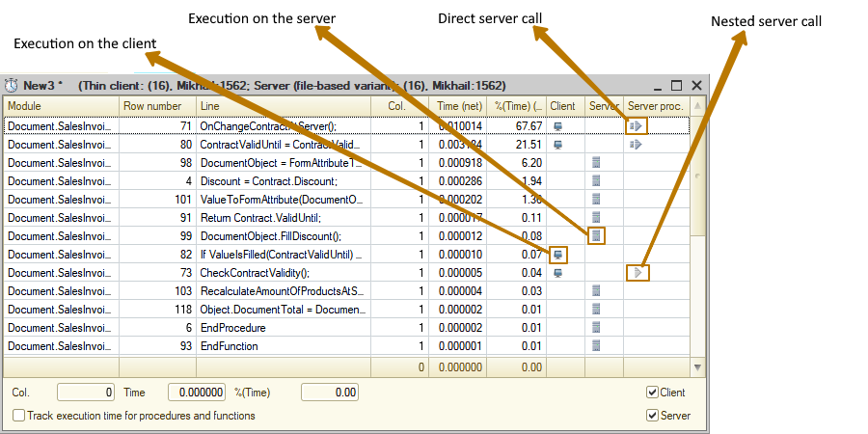
Runtime for each string in the performance snapshot is made up of runtime of string operators ("net time") and call time of the procedure/function, if there are any in the string. You can select “Track execution for procedures and functions” checkbox to choose the time to display: full time (as a sum of call time and "net time") or "net runtime".
If a string contains at least one procedure (function) call, the runtime includes runtime of string operators and call time of the procedure (function).
If the check box is selected, the procedure (function) call time is included in the total execution time.
If this check box is cleared, the measurement result includes only the code line execution time, but not the execution time of the procedure (function) that is called in this line. In this case the total runtime of this line (in the Time column) does not reflect the actual time spent by the system to process this line. Please remember that execution of called procedure (function) may be time-consuming, and in this case this time is not included in the result ("net time"). The check box is selected by default and its state is saved between the sessions. If the state change, the time columns headers will change.
In the lower right corner of the form with the measurement results (see fig. 31), you can select check boxes to display the performance measurement results:
- Select the Client checkbox to display the results of code execution measurement on the client.
- Select the Server checkbox to display the results of code execution measurement on the server.
- Select the Client and the Server the checkboxes to display the results of code execution measurement on both client and server.
The checkboxes are shown if server infobase is being debugged. The check boxes are available if you are debugging a server debug item.
If there are several open windows with the performance measurement results, when you hover the mouse pointer over the results column, you can see a tooltip with the URL of the file which data is shown in this column.
If you double-click in the column with the performance measurement results in the module editor, you will move to the corresponding line in the file with the performance measurement results.
In addition to the special window, the measurement results can also be viewed in the module source code window. If a performance snapshot window is open in the debugger, a column appears in the module windows showing the number of calls for the current string and the percentage of its work to the total time.
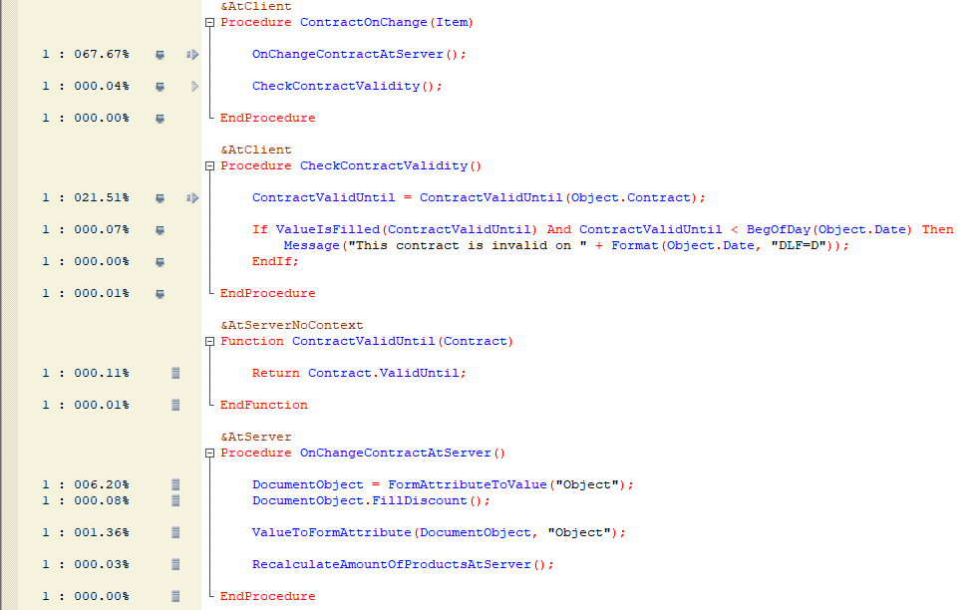
The icons show the code execution on the client or server, as well as server calls (similarly to the measurement results window).
Double-click a line in the measurement results window to switch to the corresponding line in module window.
If several measurement results are opened at the same time, the module text windows contain the corresponding number of columns with results of measurements. Closing the measurement results window removes columns with the number of calls and a percentage of working time from the modules.
Measurement results can be sorted by any column of the report. Sorting is done by clicking on the heading of one of the columns. Clicking on the headings Module or Row number sorts by row number, Col. - by the number of line calls, Time or %(Time) - by operating time. If the performance of code execution was Measured on the client and on any server, then sorting is also allowed by these columns.

